IT RCSA Audit Documentation
Business Requirement – BSI.IT.23.C1
Design Assessment, Walkthrough and Sample of One (DH 3264 – Derivatives NDF) and exception EX-C1-01 – re-performed with the 10/30/2026 evidence
DESIGN RATING | SAMPLE 3264 | CPA (PROPOSED) | EXCEPTIONS
SATISFACTORY | PASS | NEEDS IMPROVEMENT | EX-C1-01

Control | BSI.IT.23.C1 – Business Requirement (Heracles ID 50696247) – Key, Manual, In every operation
Risk | BSI.IT.23.R4 Lack of Design Phase (Inherent Moderate)
Review period | 09/01/2025 – 08/31/2026
Test date / tester | 10/30/2026 – IT RCSA
Test script | No C1 script in the IT RCSA 2026 Test Plan "New test scripts" tab – proposed 9-step script in the Test Plan format (00 Reference) applied, aligned with the CUSO RCSA Testing Procedure (07/17/2026) and CDA Job Aid
Walkthrough | 08/13/2025 – Jose Luis Martinez Avial, Systems Development Director (prior cycle). 2026 confirmation with the control owner to be obtained in the 2026 walkthrough.
Sample of one | DH 3264 – Derivatives NDF – R01 (BRD approved 10/23/2025, PTB 11/04/2025) and R02 (BRD 12/02/2025, PTB 03/10/2026)
Evidence folder | C1 Business Req/Evidence (BSI.IT.23.C1.01 – C1.15; C1.13 – C1.15 new on 10/30/2026)

1. Design Effectiveness Summary
The control design is effective. The control is triggered for every SDLC project / release ("In every operation") during the Define phase (process map step 1.1): the Project Manager documents the functional and non-functional requirements in the US PMO BRD template and obtains the Business Sponsor's e-mail approval, which is embedded in the BRD and uploaded to Delivery Hub before the Gate 4 – Prepare to Build (PTB) disposition. Placing the approval before PTB is appropriate to prevent building systems on undocumented or unapproved requirements (R4). Manual nature is appropriate – the sponsor reviews and approves the requirements.
HERACLES question | Answer | Rationale (2026)
1 Frequency / trigger | Yes | Every SDLC project/release, before Gate 4 (PTB).
2 Audit trail / evidence | Yes | BRD with embedded sponsor approval e-mail; Delivery Hub gate dispositions (C1.03 – C1.13).
3 Policy alignment | Yes | SDLC process map step 1.1 (C1.01) / US SDLC Standard; map v2.0 Draft (OBS-01).
4 Thresholds | N/A | Applies to every SDLC project.
5 Escalation | Full | Phase checkpoints by the PM; PMO QA (e.g. C1.14); monthly TWG status.
6 Information reliability | Moderately Reliable | Manual e-mail approvals; NFR sections often "NA"; BRD versioning inconsistent (OBS-02).
7 Evidence obtainable | Yes | Delivery Hub documents / screens provided by the PMO on request.

Design observation OBS-06: the control statement lacks the who / evidence / escalation elements identified in the Test Plan Control Articulation Tracker; adopt the 2026 proposed statement, including documented sponsor amendment for requirement changes after PTB (this would have addressed EX-C1-01).

2. WT Summary
No 2026 walkthrough meeting was held for this cycle; the design understanding is based on the 08/13/2025 walkthrough with Jose Luis Martinez Avial, the 2026 process map (v2.0 Draft, 05/20/2026) and the evidence received on 10/21/2026 and 10/30/2026.
Model walkthrough language (RCSA CDA Job Aid §4.1): On 10/30/2026, IT RCSA performed a Test of One for BSI.IT.23.C1 through inspection of DH 3264 Derivatives NDF (Releases 01 and 02), selected from the Delivery Hub SDLC Project List for 09/01/2025 – 08/31/2026. The control is triggered by each SDLC project / release and performed in every operation by the Project Manager (Domingo Megia Planet), with approval by the Business Sponsor (Ted Fernandez, Treasury). The tester reviewed the BRDs (v1.0 09/10/2025; RL2 v1.0 12/02/2025), the sponsor sign-off e-mails (10/23/2025; 12/02/2025) and the Gate 4 (PTB) approvals (11/04/2025; 03/10/2026), which demonstrate the requirements were defined and approved before Build. Evidence is retained in Delivery Hub. When requirements are missing or change, the PMO requires re-documentation and sponsor approval (C1.14). Additional iteration: DH 3263 Security Lending – exception EX-C1-01 on R01 (Section 4). The control is appropriately designed to mitigate R4 because sponsor approval is a prerequisite of the PTB gate.
Competency (Job Aid §4.4): the PMs and the Business Sponsor demonstrated knowledge of the BRD template, the sponsor approval and the gate prerequisites; the PMO (Joshua De Leon) applied QA to the Security Lending artifacts. To be re-confirmed with the control owner.

3. Sample of One – DH 3264 Derivatives NDF
Workpaper column | Value / conclusion | Evidence reference | Result
Sample ID | 2 (CPA row 54) | Workpaper CPA tab | Pass
R01 BRD – functional | BR 1 – BR 10 (T24 NDF set-up, pre/post-trade checks, confirmations, Murex/Medea/360, DTCC, reconciliations) | C1.07 | Pass
R01 BRD – non-functional | Security (ISAR SAT-4161), Auditability, Backup & Recovery (RTO 0-8h / RPO 0-4h), Availability | C1.07 | Pass
R01 sponsor approval before Build | Ted Fernandez 10/23/2025 → Gate 4 PTB approved 11/04/2025 | C1.08; C1.09 | Pass
R02 BRD – functional / NFR | BR 1 – BR 4; Security, Backup & Recovery, Availability | C1.10 | Pass
R02 sponsor approval before Build | Ted Fernandez 12/02/2025 → Gate 4 PTB approved 03/10/2026 | C1.11; C1.12 | Pass

4. Exception EX-C1-01 – DH 3263 Security Lending R01 (Appian)
Date | Event | Evidence
08/01/2025 | Gate 3 PTP (release ALL) – approval 10/01/2025 | C1.13
10/31/2025 | Gate 4 PTB (release ALL) – Build phase starts | C1.13
12/12/2025 – 12/17/2025 | RLSE1271544: functional doc / test strategy attached; pre-production date (Appian build) | C25.03
02/03 – 02/09/2026 | PM / PMO e-mails: Appian release created because the release 1 business artifacts did not mention Appian; focus on business artefacts | C1.14
02/06/2026 | Appian BRD "FINAL" approved by Ted Fernandez | C1.04
03/13/2026 | RLSE1271544 deployed to production | C25.03

Evaluation (RCSA Testing Procedure §4.4.8): requirements for the Appian workflow were approved after Build started – attribute 2 fails for R01. Nature: requirements omitted from the phase 1 BRD and re-documented later; extent: 1 of 4 releases; partially compensated by PMO QA and sponsor approval before production. The full population was tested, so no additional sample is available. Proposed CPA rating: Needs Improvement, to be discussed with the reviewer and communicated to the Control Owner and BU BCO for written agreement (§4.3.6). Management may rebut by providing the phase 1 BRD approval covering the Appian requirements (OI-01).

NewTest Script coverage (workpaper tab "New Test Script")
Step | Test script step | Answer | Result
1 | Obtain Evidence | BRDs, approvals, gate records, e-mail chains | Completed
2 | Completeness & Accuracy | Accuracy traced; independent release list not provided (OBS-11) | Pass – OBS-11
3 | Population & Scope | 2 projects / 4 releases – 100% | Completed
4 | Control Execution | NDF R01/R02 & SL R02 approved before Build; SL R01 after | Fail – EX-C1-01
5 | Control Results | Approvals by the Business Sponsor, stored in Delivery Hub | Completed
6 | Exception Handling | EX-C1-01 evaluated (root cause, extent, impact) | Exception
7 | Escalation & Remediation | PMO QA escalation; CO / BCO agreement to follow | Done
8 | Risk Mitigation | Partially mitigated | Partially
9 | Testing Coverage | Documented in workpaper | Completed

Appendix A – Evidence
Exhibit A1: Delivery Hub gate dispositions – DH 3263 Security Lending (BSI.IT.23.C1.13)
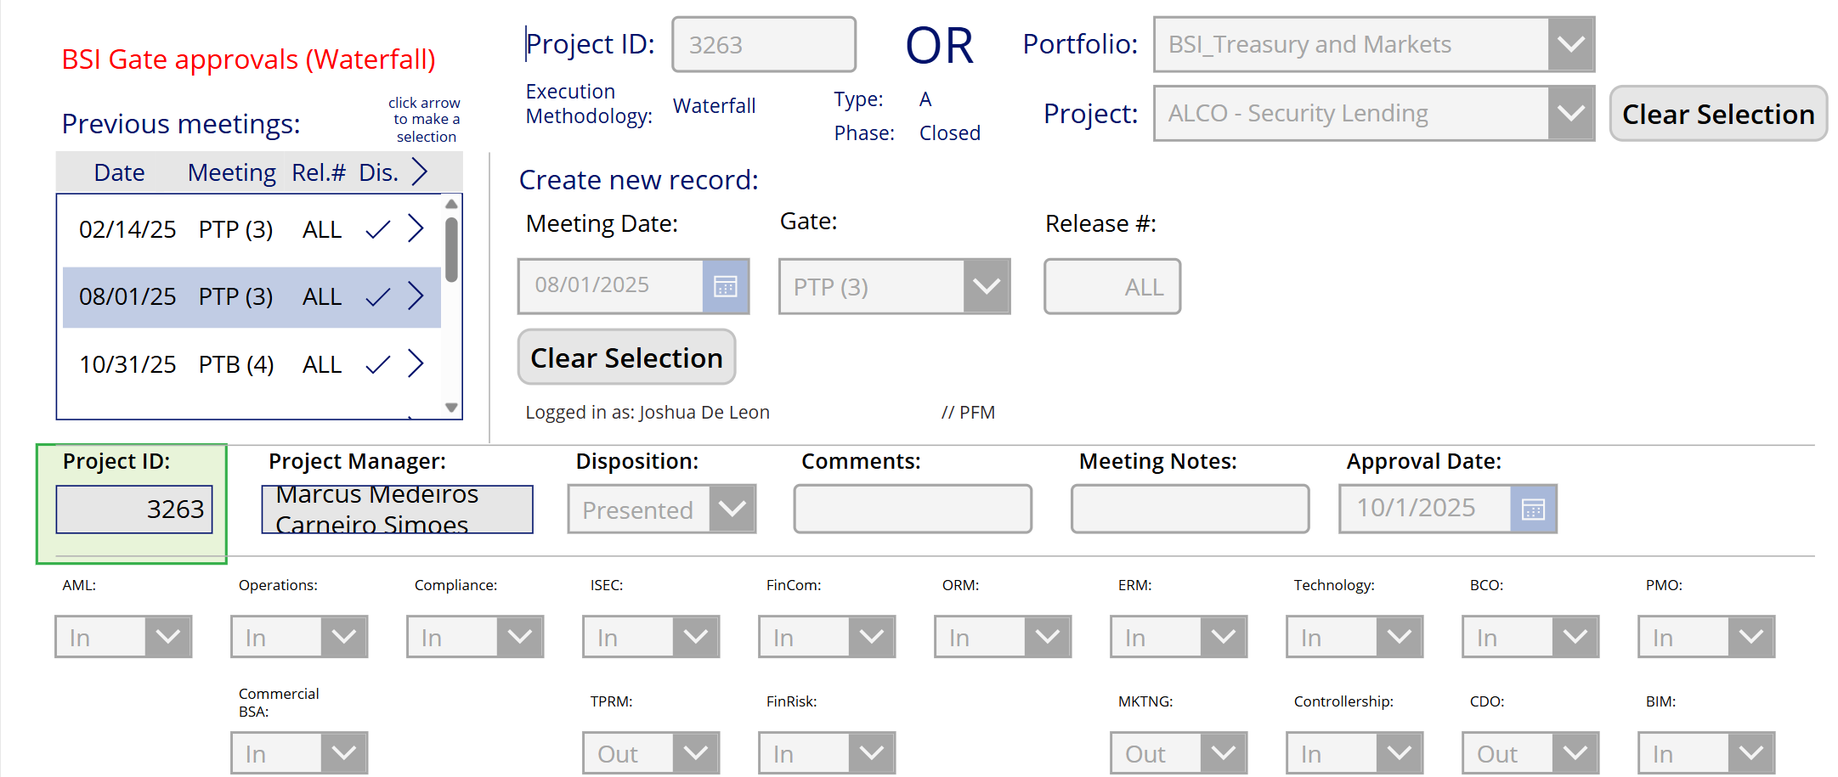
Source: BSI.IT.23.C1.13 (copy of C13.05, image 2). Previous meetings: PTP (3) 02/14/25, PTP (3) 08/01/25, PTB (4) 10/31/25 – release ALL.
Exhibit A2: PMO e-mail 02/09/2026 9:57 AM ET – Joshua De Leon (BSI.IT.23.C1.14)
"This project is going through a release 2 as it was identified that within the friends and family release, some of the business required artifacts did not mention Appian verbiage. For this reason, a release 2 is being documented." – Marcus Medeiros 02/06/2026: "the focus of release 2 is on the business artefacts solely."
Referenced workbook: C1 WP 2026.xlsm – tab "Control Performance Assessment", rows 53 – 54; tab "New Test Script".

